Course Report
2-week customized course on
“RS & GIS Technologies for Sustainable Watershed Management”
(07th Feb – 18th Feb 2022)

National Hydrology Project (NHP) is taken up by the Ministry of Jal Shakti, Department of Water Resources, RD & GR, Govt. of India, and the mission objective is to aid in effective water resources planning, development and management. This project is intended for setting up of a system for timely and reliable water resources measurement, storage, monitoring and management. It will also facilitate to provide tools/systems for informed decision making through Decision Support Systems (DSS) for water resources management, flood management, reservoir operations, drought management, etc. NHP also takes care of capacity building of the relevant State and Central government organizations in water resources management through the use of Information Systems and adoption of State-of-the-art technologies like Remote Sensing & GIS.
National Remote Sensing Centre (NRSC) has taken up the task to support NHP based on the request from Ministry of Jal Shakti, Department of Water Resources, River Development & Ganga Rejuvenation (MoJS, Dept. of WR, RD&GR) through organizing capacity building training programs comprising of Remote Sensing & GIS technologies and customized applications on water resources. These programs are aimed at capacity building of all the stake holders in understanding and effective utilization of space technology in the field of water resources. To this effect, two customized training programs per year of one week duration on the fundamentals aspects of RS & GIS and two customized programs per year of two weeks duration on the applications of RS & GIS in water resources are planned.
In this regard, a two-week customised training programme on ‘Remote Sensing & GIS Technologies for Sustainable Watershed Management’ was conducted at National Remote Sensing Centre by Water Resources Group in association with Training, Education & Outreach Group, Geosciences Group and Rural Development & Watershed Management Division for water resources engineers of Central / State government departments under National Hydrology Project during 07-Feb-2022 to 18-Feb-2022. Due to Covid-19 pandemic situation across the country the training programme was conducted in Webinar mode. The details of which are described below.
The training programme was inaugurated on 07-Feb-2022 by Dr. Raj Kumar, Director, NRSC and Dr.V.V. Rao, Deputy Director, Remote Sensing Applications Area, NRSC. Shri.P.V.Raju, Group Director (WRG) welcomed all the participants and gave overview of the training programme. Dr.V.V. Rao, DD (RSAA) and Project Director (NHP) briefed about the training programme including NHP activities. Dr. Raj Kumar, Director, NRSC delivered key note address to the participants. A total of 49 officials participated in this course from water resources departments of both Central and State Governments (refer Annex-1).
The course is designed in such a way that it covers the overall concepts of remote sensing and GIS, besides theoretical and practical knowledge on the subject of sustainable watershed management, starting from the fundamentals of Remote Sensing and GIS till sustainable watershed management using geospatial data inputs (refer Annexure-2). During the first day, the participants were introduced to remote sensing, image interpretation techniques and hands-on exercises on image interpretation techniques in the afternoon sessions. Second day, topics on GIS were covered which includes introduction to GIS, Spatial data analysis techniques along with hands on exercises in afternoon sessions. On third day the topics covered include DEM concepts & applications in watershed, open sources GIS (QGIS), demo cum hands on exercise in QGIS. A guest lecture on ‘Integrated Watershed Management: A Strategy for Development of Rainfed / Degraded Land’ was special arrangement to the trainee participants on fourth day. In addition fourth day, topics covered are role of RS & GIS technologies on sustainable management of watersheds, estimation of water availability using SWAT for a watershed, hands-on exercise on estimation of water availability using SWAT for a watershed. Fifth day the hands-on exercise on estimation of water availability using SWAT for a watershed was continued.
Sixth day the participants were taught on hydrogeological inputs for optimization of sites for recharge structures, integrated geohydrological analysis and modelling for site suitability of recharge structures for ground water sustainability and hand-on exercise site suitability for water recharge structures. A guest lecture on ‘Sustainable ground water/water resources planning of Rural micro-watershed- A case study’ was arranged on seventh day. In addition seventh day covered ‘Integrated Multi Criteria Decision Analysis technique for site suitability of check dams using ground water prospects maps and hands-on exercise on MCDA technique for site suitability for ground water recharge structures. Eighth day topics covered include water harvesting structures Inventory, Monitoring and Impact evaluation, Journey of MGNREGA towards G-Governance, and hands-on exercises on Water harvesting structures for Inventory, Monitoring and Impact evaluation. A guest lecture on ‘Rain Water Harvesting Technologies at Watershed Scale - Design, Development & Impact Evaluation’ was also arranged on eighth day. The ninth day covers Introduction to Pilot study and hands-on exercises on Water harvesting structures for Inventory, Monitoring and Impact evaluation. The tenth day topics covered include satellite data products & dissemination, open source data & software for water resources, water resources information portals, and the participants were shown demos on BHUVAN (covering topics like Watershed Applications, Bhuvan Bhujal, AIBP, WBIS, etc.).

Feedback was obtained from all the participants on the overall training programme and on each topic-wise. The trainees expressed happiness for including more hands on practical exercises in this training programme. The ratings are very good and the overall course feedback is 4.5 out of 5.
The concluding session was held on 18-Feb-2022, chaired by Dr.V.V. Rao, Deputy Director, RSAA, NRSC and co-chaired by Shri.P.V.Raju, Group Director (WRG), NRSC. The Training Programme was concluded with feedback from the Trainee Officers and remarks by the chair and co-chair.

Photograph taken during Inaugural Session of Webinar
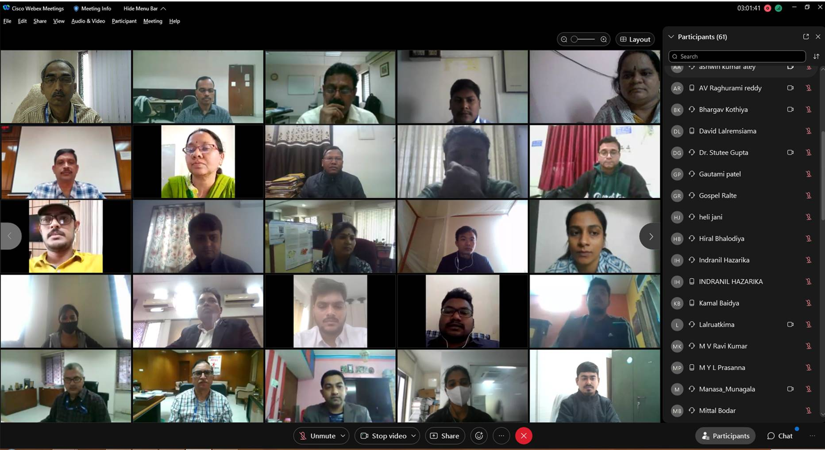
Photograph taken during Concluding Session of Webinar
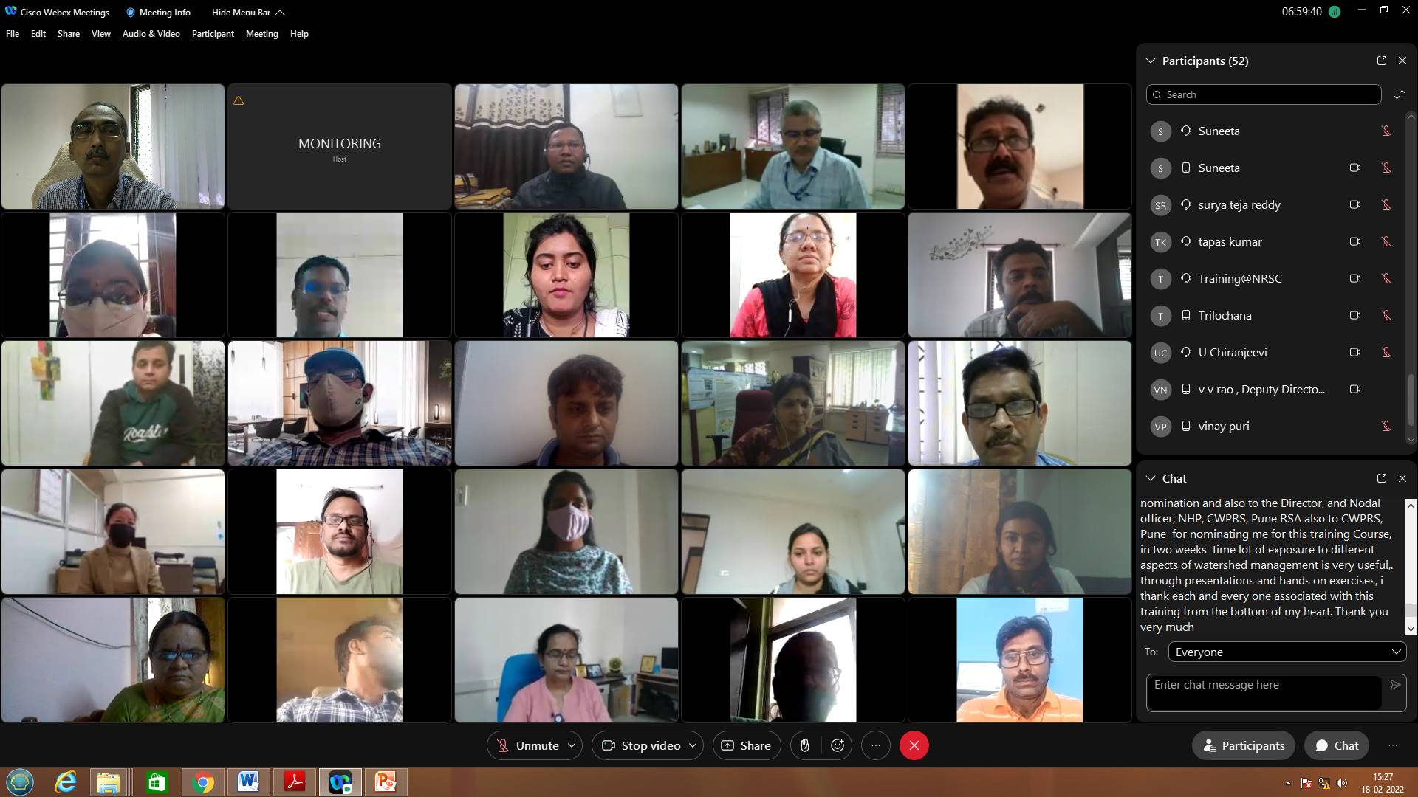
Annexure 1

List of Officers attended the Training Programme

S.No | Name | Designation | Organization | City
01 | Ms.A Jyothirmaye | Geologist | Ground Water and Water Audit Department, Government of Andhra Pradesh | Kakinada
02 | Mr.P Harish | Assistant Geophysicist | Ground Water and Water Audit Department, Government of Andhra Pradesh | Guntur
03 | Ms.K Swarna Chandrika | Assistant Engineer (Civil) | Ground Water and Water Audit Department, Government of Andhra Pradesh | Eluru
04 | Mr.A V Raghurami Reddy | Assistant Engineer | Ground Water and Water Audit Department, Government of Andhra Pradesh | Vijayawada
05 | Mr.U Chiranjeevi | Assistant Hydrogeologist | Ground Water and Water Audit Department, Government of Andhra Pradesh | Vijayawada
06 | Mr.K Surya Teja Reddy | Assistant Hydrologist | Ground Water and Water Audit Department, Government of Andhra Pradesh | Ongole
07 | Ms.M Kalavathi Bai | Assistant Hydrologist | Ground Water and Water Audit Department, Government of Andhra Pradesh | Eluru
08 | Ms.M Yoga Lakshmi Prasanna | Hydrogeologist | Ground Water and Water Audit Department, Government of Andhra Pradesh | Kakinada
09 | Mr.Dasari Chaitanya | Assistant Executive Engineer | Water Resources Department, Government of Andhra Pradesh | Kurnool
10 | Ms.Ponnada Bala Tripura Sundari | Assistant Executive Engineer | Water Resources Department, Government of Andhra Pradesh | Guntur
11 | Mr. M D Ananda Babu | Assistant Executive Engineer | Water Resources Department, Government of Andhra Pradesh | Vijayawada
12 | Ms. Manasa Munagala | Assistant Executive Engineer | Water Resources Department, Government of Andhra Pradesh | Vijayawada
13 | Ms.Anusha Modurouthu | Assistant Executive Engineer | Water Resources Department, Government of Andhra Pradesh | Vijayawada
14 | Mr. Saikiran Saravakota | Assistant Executive Engineer | Water Resources Department, Government of Andhra Pradesh | Nellimarla
15 | Mr.Pranab Baruah | Assistant Engineer | Water Resources Department, Government of Assam | Tezpur
16 | Mr. Ashwin Kumar Atey | Hydrogeologist | Central Ground Water Board | Nagpur
17 | Mrs. Priti D Raut | Scientist B | Central Ground Water Board | Nagpur
18 | Mr. Anukaran Kujur | Scientist B | Central Ground Water Board | Ranchi
19 | Mr.Sujatro Ray Chowdhuri | Scientist B | Central Ground Water Board | Lucknow
20 | Mr.Vipin Kumar Mishra | Hydrogeologist | Central Ground Water Board | Allahabad
21 | Mr. Tapas Kumar Sahoo | Assistant Hydrogeologist | Central Ground Water Board | Kolkata
22 | Mr. Prince Awadhiya | Junior Engineer | Water Resources Department, Government of Chattishgarh | Raipur
23 | Ms.Khushbu Yadav | Geo-Hydrologist | Water Resources Department, Government of Chattishgarh | Raipur
24 | Ms.Anuja Rajagopalan | Scientist B | Central Water & Power Research Station | Pune
25 | Ms.Suneeta Jatwa | Scientist C | Central Water & Power Research Station | Pune
26 | Ms.Ripal Sanatbhai Chavda | Assistant Engineer | Water Resources Department, Government of Gujarat | Gandhinagar
27 | Mr.Parth Patel | Assistant Engineer | Water Resources Department, Government of Gujarat | Gandhinagar
28 | Ms.Sheetal Solanki | Assistant Engineer | Water Resources Department, Government of Gujarat | Gandhinagar
29 | Ms.Mittal Bodar | Assistant Engineer | Water Resources Department, Government of Gujarat | Gandhinagar
30 | Mr.Bhargav Kothia | Deputy Executive Engineer | Water Resources Department, Government of Gujarat | Gandhinagar
31 | Mr.Vinay Puri | Assistant Engineer | Narmada Water Resources, Water Supply & Kalpsar Department, Water Resource Investigation | Ahmedabad
32 | Mr. Ashvin Baraiya | Assistant Engineer | Water Resources Department, Government of Gujarat | Bhavnagar
33 | Ms.Heli Jani | Assistant Engineer | Water Resources Department, Government of Gujarat | Gandhinagar
34 | Ms.Gautami Patel | Assistant Engineer | Water Resources Department, Government of Gujarat | Gandhinagar
35 | Mr.Hiral Bhalodiya | Assistant Engineer | Water Resources Department, Government of Gujarat | Gandhinagar
36 | Ms.Shruti Halli | Research Assistant | Water Resources Department, Government of Karnataka | Bengaluru
37 | Mr.Arun Das B | Hydrogeologist Jr. | Ground Water Department , Government of Kerala | Idukki
38 | Mr.Lalruatkima | Technical Expert (GW) | Irrigation & Water Resources Department, Government of Mizoram | Aizawl
39 | Ms.Gospel Rohmingthangi | GIS Expert | Irrigation & Water Resources Department, Government of Mizoram | Aizawl
40 | Ms.Nishi R Choudhary | Research Assistant | Narmada Control Authority | Indore
41 | Ms.Namrata Patel | Research Assistant | Narmada Control Authority | Indore
42 | Ms.M Madhavi | Deputy Engineer | Irrigation & CAD Department, Government of Telangana | Hyderabad
43 | Ms.P Shailaja | Deputy Engineer | Irrigation & CAD Department, Government of Telangana | Hyderabad
44 | Ms.S Madhava Rao | Assitant Geophysicist | Ground Water Department, Government of Telangana | Hyderabad
45 | Mr.Santanu Sarkar | Junior Engineer, TES Gr- V(A) | Water Resources Department, Government of Tripura | Agartala
46 | Mr.Kamal Suklabaidya | Junior Engineer, TES Gr- V(A) | Water Resources Department, Government of Tripura | Agartala
47 | Ms.Runulipsa Barik | Asistant Executive Engineer(Civil) | Water Resources Department, Government of Odisha | Bhubaneswar
48 | Ms.Ananya Singha Ray | Asistant Executive Engineer(Mech) | Water Resources Department, Government of Odisha | Bhubaneswar
49 | Ms.Trilochana Basnett | GIS Analyst | Water Resources Department, Government of Sikkim | Gangtok

Annexure 2
PROGRAMME SCHEDULE
Date & Time | Title of the Lecture | Faculty
Day-1 : 7 February 2022 (Monday)
10:30-11:00 hrs. | Inauguration Session | RSAA & TEOG
11:00-12:00 hrs. | Introduction to Remote Sensing | Mr.PVSSN Gopala Kirshna, TEOG
12:00-13:00 hrs. | Image Interpretation & Classification Techniques | Mr.P Hariesh, TEOG
13:00-14:00 hrs. | Lunch Break
14:00-16:30 hrs. | Hands-on Exercise on satellite Image Interpretation | Mr.P Hariesh, TEOG
Day-2 : 8 February 2022 (Tuesday)
10:30-11:45 hrs. | Introduction to GIS | Mr.PVSSN Gopala Kirshna, TEOG
11:45-13:00 hrs. | Spatial Data Analysis Techniques | Mr.T S Viswanadham, TEOG
13:00-14:00 hrs. | Lunch Break
14:00-15:00 hrs. | Open Source GIS (QGIS) | Mr.P Hariesh, TEOG
15:00-16:30 hrs. | Hands-on Exercises on GIS (shape file creation & editing, point data to spatial conversion) | Mr.P Hariesh, TEOG
Day-3 : 9 February 2022 (Wednesday)
10:30-11:45 hrs. | DEM Generation Concepts and its Applications in Watershed | Mr.B Narender, AS & DMA
11:45-13:00 hrs. | Hands-on Exercises on GIS (spatial data query and analysis) | Mr.T S Viswanadham, TEOG
13:00-14:00 hrs. | Lunch Break
14:00-16:30 hrs. | Hands-on Exercises on GIS (map preparation) | Mr.T S Viswanadham, TEOG
Day-4 : 10 February 2022 (Thursday)
10:30-11:45 hrs. | Integrated Watershed Management: A Strategy for Development of Rainfed / Degraded Land | Dr. C.P. Reddy  Sr. Addl. Commissioner (WD)  Department of Land Resources
11:45-13:00 hrs. | Role of RS & GIS technologies on Sustainable Management of Watersheds | Dr. T Ravi Sankar  Deputy Director, BGWSA
13:00-14:00 hrs. | Lunch Break
14:00-15:00 hrs. | Estimation of Water Availability using SWAT for a Watershed | Mrs. Annie Marie Issac, WRG
15:00-16:30 hrs. | Hands-on Exercise on Estimation of Water Availability using SWAT for a Watershed | Mr. V Yogesh Palenivel &  Mr. Visakh, WRG
Day-5 : 11 February 2022 (Friday)
10:30-11:45 hrs. | Estimation for Water Availability using SWAT for a Watershed  (Environment flows and Dependable flows) | Mrs. Annie Marie Issac, WRG
11:45-13:00 hrs. | Hands-on Exercise on Estimation of Water Availability using SWAT | Mr. V Yogesh Palenivel & Mr.Visakh, WRG
13:00-14:00 hrs. | Lunch Break
14:00-16:30 hrs. | Hands-on Exercise on Estimation of Water Availability using SWAT | Mr. V Yogesh Palenivel & Mr.Visakh, WRG
Day-6 : 14 February 2022 (Monday)
10:30-11:45 hrs. | Understanding hydrogeological inputs for optimization of sites for recharge structures | Dr. I C Das, GSG
11:45-13:00 hrs. | Integrated geohydrological analysis and modeling for site suitability of recharge structures for ground water sustainability | Mr. Rajarshi Saha, GSG
13:00-14:00 hrs. | Lunch Break
14:00-16:30 hrs. | Hands-on Exercise on Site suitability for water recharge structures | Mr. Rajarshi Saha &  Mr. T Wankhede, GSG
Day-7 : 15 February 2022 (Tuesday)
10:30-11:45 hrs. | Sustainable ground water/water resources planning of Rural micro-watershed- A case study | Dr. Ranga Rajan,  Former Scientist, NGRI
11:45-13:00 hrs. | Integrated Multi Criteria Decision Analysis technique for site suitability of check dams using ground water prospects maps | Mr. R Majumdar, GSG
13:00-14:00 hrs. | Lunch Break
14:00-16:30 hrs. | Hands-on Exercise on MCDA technique for Site suitability for ground water recharge structures | Mr. T Wankhede, GSG
Day-8 : 16 February 2022 (Wednesday)
10:30-11:45 hrs. | Water harvesting structures Inventory, Monitoring and Impact evaluation | Mr. B Shyamsunder, RDWMD
11:45-13:00 hrs. | Journey of MGNREGA towards G-Governance | Dr. Girish Shankar Pujar, RDWMD
13:00-14:00 hrs. | Lunch Break
14:00-15:00 hrs. | Rain Water Harvesting Technologies at Watershed Scale - Design, Development & Impact Evaluation | Dr. K Srinivas Reddy  Principal Scientist, CRIDA
15:00-16:30 hrs. | Hands-on Exercises on Water harvesting structures for Inventory, Monitoring and Impact evaluation | Dr. Stutee Gupta, RDWMD
Day-9 : 17 February 2022 (Thursday)
10:30-11:45 hrs. | Role of Capacity Building in IWMP/MGNREGA | Dr. P. Kesava Rao  Head, Centre for Geoinformatics Application in Rural Development, NIRD
11:45-13:00 hrs. | Introduction to Pilot study | Dr. Stutee Gupta, RDWMD
13:00-14:00 hrs. | Lunch Break
14:00-16:30 hrs. | Hands-on Exercises on Water harvesting structures for Inventory, Monitoring and Impact evaluation | Dr. Stutee Gupta, RDWMD
Day-10 : 18 February 2022 (Friday)
10:30-11:15 hrs. | Satellite Data Products & Dissemination | Mr. G Someswara Rao, NDC
11:15-12:15 hrs. | Open Source Data & Software for Water Resources | Mr. Saksham Joshi, WRG
12:15-13:00 hrs. | Water Resources Information Portals | Mr. Anurag Mishra, WRG
13:00-14:00 hrs. | Lunch Break
14:00-16:00 hrs. | Introduction to Bhuvan and Demo (Watershed Applications, Bhuvan Bhujal, AIBP, WBIS, etc.) | Mr.Sai Rama Krishna, BGWSG
16:00-16:30 hrs. | Valedictory | RSAA & TEOG

AS & DMA: Aerial Services & Data Management Area | NDC: NRSC Data Centre
BGWSG: Bhuvan Geo-portal & Web Services Group | TEOG: Training, Education & Outreach Group
GSG: Geo-Sciences Group | WRG: Water Resources Group
RDWMD: Rural Development & Watershed Monitoring Division

***

